# 5. Documentation and seeking feedback

## 5.1 Troubleshooting Task

Use the below template to create user documentation with instructions on how to create a new EC2 instance.

**How to Create a New EC2 Instance**

**This guide will walk you through creating a virtual machine (EC2 instance) on AWS step by step. Follow these instructions carefully.**

**Step 1: Log in to the AWS Management Console**

1. Open your web browser and go to the [AWS Management Console](https://aws.amazon.com/console/).
2. Enter your Username and Password, then click Sign In.

**Step 2: Open the EC2 Dashboard**

1. In the Search bar at the top of the page, type EC2.
2. Select EC2 from the dropdown menu.

**Step 3: Launch a New Instance**

1. On the EC2 Dashboard, click the Launch Instance button.

1. Enter a name for your instance, e.g., Erfys-WebServer.

**Step 4: Choose an Amazon Machine Image (AMI)**

1. Under the Amazon Machine Image (AMI) section, select Amazon Linux 2.
   * This is a free-tier eligible option.
   * It’s a lightweight and secure operating system.

**Step 5: Select an Instance Type**

1. Choose t2.micro for the instance type.
   * This is free-tier eligible and sufficient for basic tasks.

**Step 6: Configure Key Pair (Secure Login)**

1. Under Key Pair, click vockeyA screenshot of a computer

   Description automatically generated

**Step 7: Configure Network Settings**

1. Ensure the instance is in the correct VPC.
2. Enable auto-assign public IP if you want the instance accessible over the internet.
3. Security Group Settings:
   * Allow the following inbound rules:
     + SSH (Port 22): For secure login (set source to your IP).
     + HTTP (Port 80): For web traffic.

**Step 8: Launch Your Instance**

1. Review all the settings.
2. Click the Launch Instance button.

**Step 9: Check Instance Status**

1. Go back to the Instances section in the EC2 Dashboard.
2. Look for your instance and wait until its status changes to Running.

**Step 10: Connect to Your Instance**

1. Select the instance in the EC2 Dashboard.
2. Click the Connect button at the top.

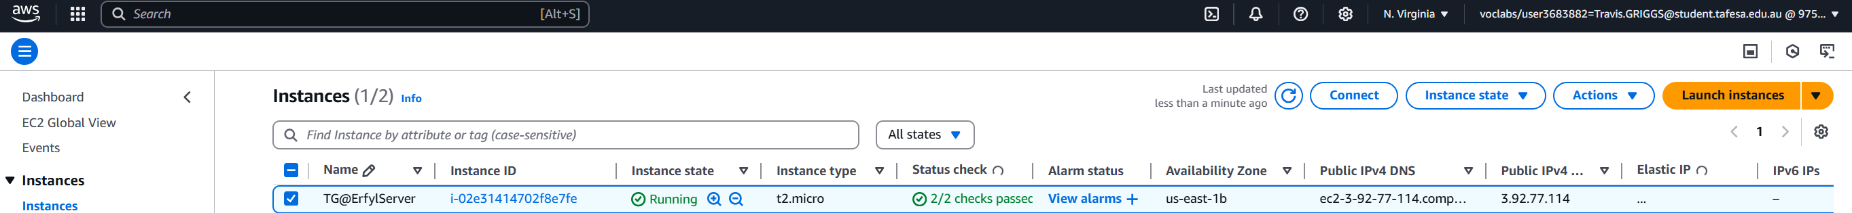

1. Choose EC2 Instance Connect for a simple browser-based terminal.
2. Click Connect to open a session.

